# Chapter 1 – Introduction

The purpose of this book is to equip .Net development teams with a complete roadmap to a high-performing DevOps process using Microsoft technologies. This book is not about any one product or tool. It is not about one particular practice or method. This book is about bringing all the tools and frameworks Microsoft and the industry has to offer into the fold. This book is about applying the relevant practices and methods in an effective way in order to achieve a software delivery process that is second-to-none. If you lead a software team and want to deliver and operate software like companies you’ve only read about, read on. My goal for you is to enable your team to deliver twice as much as before. If you are just starting your development career, my goal for you is to help you gain 5-10 years of experience by the application of this text.

## Principles

I will start with principles, because any technical work that we do must be guided by principles if others are to align with our work. Without guiding principles, a team cannot become a team. The team will have no culture, and each team member will be tugging in different directions.

### DevOps Principles

In his popular book, [The Phoenix Project: A Novel About IT, DevOps, and Helping ...](https://www.amazon.com/Phoenix-Project-DevOps-Helping-Business-ebook/dp/B00AZRBLHO)[1], Gene Kim enumerates three guiding principles of DevOps. He names them “The Three Ways”. They are:

1. The First Way: Systems Thinking
2. The Second Way: Amplify Feedback Loops
3. The Third Way: Culture of Continual Experimentation and Learning

These are quite abstract, but they have complex implementations, and we will be tackling how to implement each of these principles throughout this book

### The Challenge of Explosive Growth

By any measure, the number of professional developers has exploded over the last decade, surpassing the growth rate of the previous decade. In Stack Overflow’s 2018 survey, we can see that over half of professional developers entered the industry in the last five years.

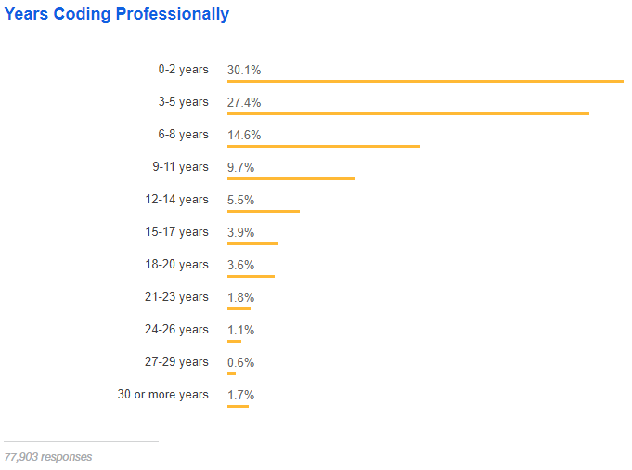

Figure: Over half of developers have five years of professional coding experience or less – Stack Overflow

If you have surpassed 20 years of development experience, you qualify at the top 5.2% of experience in the industry. We can see the inflection point between the 6-8 years and 3-5 years of experience. It’s unclear how the growth will continue or if business demand will start to be saturated. Regardless of future growth, we have a challenge in our industry created by this explosive growth in the workforce.

Consider this analogy. You are opening a new auto mechanic shop.



Figure :An auto mechanic shop must be set up in a way conducive to delivery quality and speed.

You purchase a fantastic location on a main road close to other centers of business. You spare no expense building the shop. You contact a local mechanic trade school and declare you wish to hire the top 7% of up-coming graduating class. You have budgeted for whatever pay it takes to hire the best and the brightest who have just been trained as new mechanics.

Along comes graduation day, and the next week, you are preparing to open for business. You gather in front of the shop next to pallets of just-delivery tools and shop equipment. You brief your new workforce expressing excitement saying, “Let’s get the shop ready for opening. We start serving customers next week.” Your staff’s excitement turns to fear with wide eyes. Your grand opening is a disaster, and you wonder what you missed.

This manager hired staff who had been trained in how to fix and service automobiles. They were smart, skillful and motivated. They were trained in an environment that was expertly configured. Alas, the curriculum did not include how to set up a new environment for themselves.

Unfortunately, more than a few team leaders and managers have experienced a similar situation. These teams have developers who know how to apply their training and practice. But in every trade that builds something, the jobsite, or environment, has a profound effect on the effectiveness of the team. This book will equip you to build a highly effective DevOps environment for your team.

## DevOps Methodology

In this industries lies much confusion about DevOps. Having only been named as such in 2010, DevOps has been commercialized and marketed. We will cover DevOps more in Chapter 3. For now, we’ll discuss the common glyphs and overviews. Wikipedia shows this process when you search for DevOps.

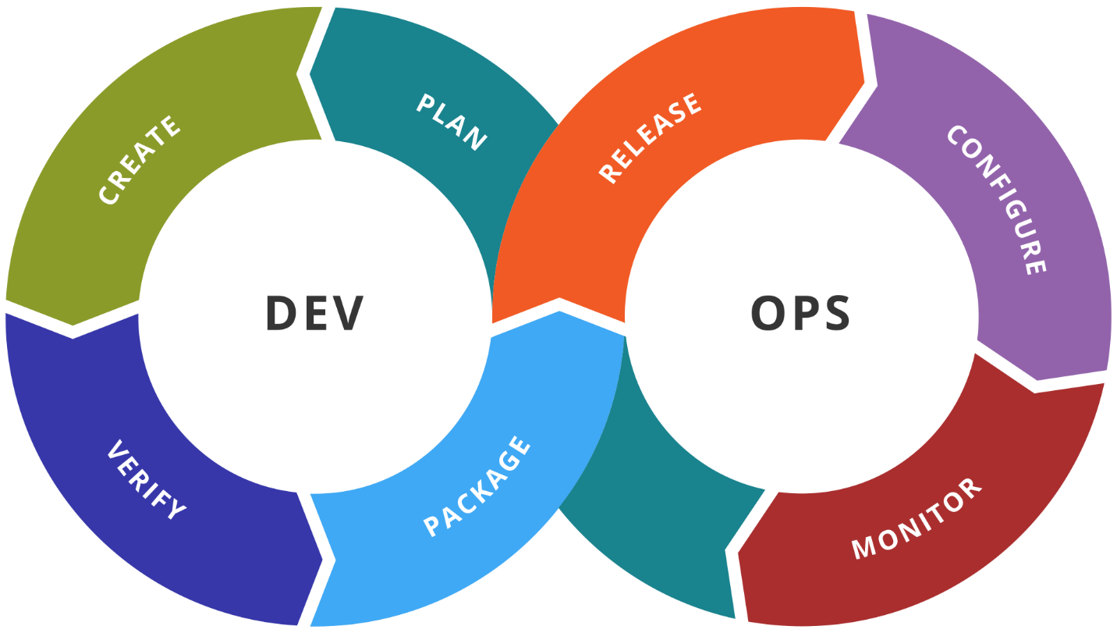

Figure : Illustration showing stages in a DevOps toolchain

Wikipedia relates that DevOps is a process with these stages, moving through Dev and Ops teams

If you read the books that introduced DevOps to the world, you’ll see that this definition illustrates some of The First Way and touches on The Second Way a bit.

### The First Way: Systems Thinking

The DevOps methodology is based on the principles known as The Three Ways. The First Way is Systems Thinking.

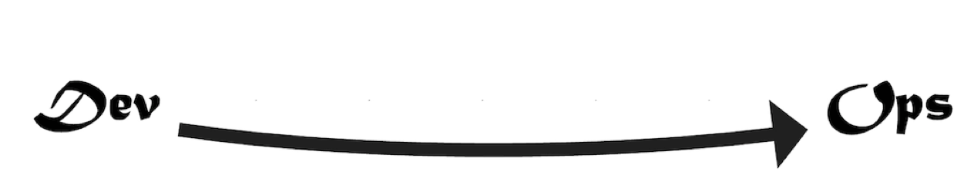

Figure: TODO: recreate graphic - The First Way is Systems Thinking

There is a lot of thought packed into this first principle of DevOps. It encompasses the ability to create a smooth, predictable flow of working software from the imagination of the developers to the active use of the customer. In our world, regardless of job description or job title, if you are involved in building or changing the software, you are on the side of Dev. If you are someone who uses or consumes or depends on the software, then you are on the side of Ops. Other definitions of DevOps that don’t actually include the user are at great risk.

### The Second Way: Amplify Feedback Loops

In this principle, we create an environment where those using our software – those operating their business or departments with our software – provide continual feedback to those developing and changing the software.

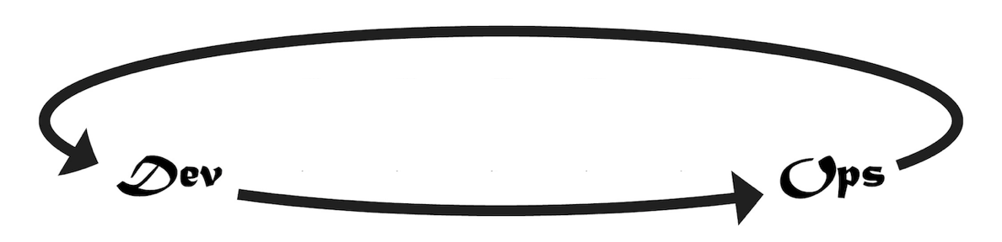

Figure: Those operating their departments using our software provide continual feedback to those changing the software.

We can put ourselves in the right DevOps mindset by translating the keywords as follows:

* Dev: Includes anyone who works to build, change, improve the software or system
* Ops: Includes anyone who relies on the software to operate their business or department

If our company has a department known as IT Operations, or Support, or Data Center Operations, it’s important not to confuse these groups as our customer. They don’t use the software. They are merely part of our development capability. The capability to deliver valuable software to our customer so that our customer can operate the software in order to experience its value.

### The Third Way: Culture of Continual Experimentation and Learning

If the first two Ways were about completing a software release cycle in a streamlined and effective way, The Third Way is about making that cycle faster.

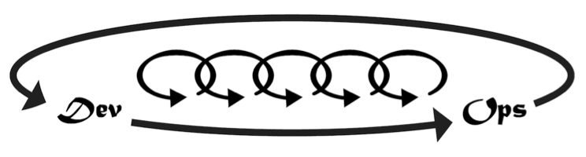

Figure: The Third Way introduces smaller cycles within the cycle

Companies such as Netflix showed us that software can be released not only daily but many times per day with no downtime and no defects. The Third Way causes us to think with that end in mind, solving any challenges that would prevent us from this ability. Even if the customer doesn’t want software releases at that cadence, this way of thinking causes us to gain this capability so that we are ready on a moments notice to release the software as it stands, always stable, always working, always bug-free. This way of thinking also encourages us to stop thinking about software releases as a big ceremony. We will see in the coming chapters how to equip our teams with the ability to release changes big and small. We will see that the same process needed for small changes is effective for large changes when every small change has made a trip down the DevOps pipeline.

## In Practice

Given all the above, what do we actually do, in practice? In order to answer that, lets take a look at the different types of software we are working on and where we want it to work.

### Application Runtime Architectures

You are building software with Visual Studio. Regardless of some libraries or frameworks you might choose, you have a finite set of runtime architectures to choose from. Popular today is a web architecture which consists of a ASP.NET web application and a SQL Server database. Or you might have a desktop WPF application communicating to ASP.NET Web API services that then use a SQL Server database. If you have an iPhone app, that might connect to your Web API services. Regardless of the combination of runtimes you take advantage of, the Microsoft platform has a finite set of choices, and the Azure cloud has a handful of ways to run each.

|  |  |
| --- | --- |
| Application architecture | Production Runtime |
| ASP.NET MVC | IIS/Azure App Service, etc. |
| ASP.NET Web Api | IIS/Azure App Service, etc. |
| SignalR | IIS/Azure App Service, etc. |
| Razor Pages | IIS/Azure App Service, etc. |
| SPA(Razor Components, Angular, React) | IIS/Azure App Service, etc. |
| Windows Service | VM, Webjob, Azure Function, etc. |
| Scheduled EXE | VM, Webjob, Azure Function, etc. |
| SQL Database | Azure SQL, Cosmos DB |

Table: A small illustration of Azure runtimes covering the breadth of application architectures.

While this table is nowhere near being complete, we can see that through web applications, offline jobs, and a relational database, we cover a high percentage of applications out in the wild. WPF, Winforms, and native iOS and Android applications are also supported by a small number of options. With each of these application types, we can choose a full range of runtime options from Infrastructure as a Service (IaaS) to Platform as a Service (PaaS).

The architectural point to consider when designing a DevOps capability is to realize that while implementing The First Way, we need not support an unique configuration for every team or application. Once we understand how to deliver a web application of some form with a SQL database out to Azure, how many of our applications are now covered? I would venture to guess for each of you dear readers, that a high number of your applications use those architectural components. We then add a capability for off-line jobs such as Windows Services and Scheduled Tasks, and we cover a good part of the gap. Once we have these application types covered, you will see how much smaller of a leap it is to then cover your native mobile apps, and Windows deskop apps as well.

### The Necessary Tools

In order to set up a professional DevOps environment targeting Azure, you’ll need to have a few key tools to get started.

* An Azure subscription.
* Visual Studio (2019 or VSCode)
* An Azure DevOps Services org

These tools are just the starting point, and throughout this book, we’ll integrate more tools, libraries, frameworks from Microsoft, other vendors, as well as open-source repositories. Remember, DevOps is about a way of thinking that leads to an outcome of shorter lead times, shorter cycle times, and fewer disruptions. Throughout this book, we’ll put all these pieces together one-by-one.

If you are just getting started with Azure or Azure DevOps Services, read on to Chapter 2. It will quickly introduce some basic capabilities in an interactive way that doesn’t yet require you to write any scripting. But don’t stop there. The steps shown in Chapter 2 are only to introduce first-time developers. These techniques are not meant for long-term maintainability. For the professional way to set up your “shop”, move to Chapter 3 and beyond where we will go through each area in detail.

1. (Kim, Behr, & Spafford, 2013)